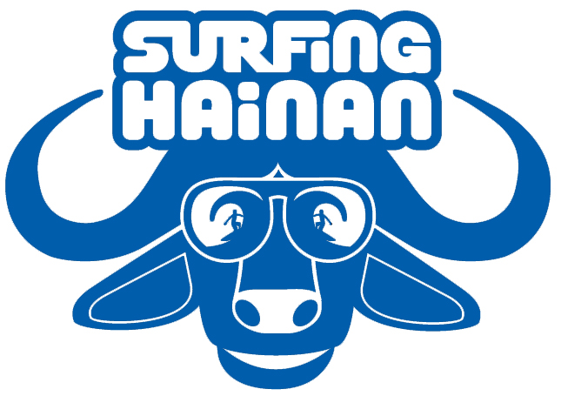


2010 O’Neill Surfing Hainan Open
Competitors Guide
Thanks for supporting the Surfing Hainan Open, now in our third year. This year’s competition will be part of a larger Hainan Surfing Festival, taking place from Saturday, Nov 6th until Monday, Nov 8th. The two days of competition for the Surfing Hainan Open will be held over Sunday and Monday, the 7th and 8th.
Rooms are available for competitors, as well as their friends and family, at the 21 Hotel in Riyuewan. Those who haven’t reserved a room yet can do so through Surfing Hainan, as we have a block of rooms reserved during the competition. A special rate of 200 rmb is available for their double room from the 5th until the 8th.
Surfing Hainan will provide transportation from our shop in Sanya to Riyuewan at 11 AM on Friday, Nov 5th and Saturday, Nov 6th for 50 rmb. Please confirm in advance if you would like to join one of these buses. There will not be room for surfboards on these buses. Please arrange other transportation if needing to bring boards up.
One can also take a taxi from the Sanya airport to Riyuewan. A taxi should be 300 to 400 rmb. Agree on a price before departing. Below are instructions for the taxi driver.
日月湾21世纪酒店：日月湾在海南东线高速公路旁，距离三亚大概100公里，到高速公路日月湾出口后顺着路往左走，左边200米远处就是21世纪酒店。 21世纪酒店电话：0898-62585588
For those wishing to take public transportation to Riyuewan . From the Bus Station on Jiefang Lu in Sanya City, get a local bus to Wanning, which is 30 km north of RYW on the Eastern expressway. Tickets are around 30 rmb. Tell the conductor you want to get off at the Riyuewan exit.
“我要在东线高速日月湾出口下车！”
From the expressway exit, walk along the off ramp to your right. Veer left when the road meets the ocean. The 21 Hotel is 200 meters on the left.

Riyuewan Map 日月湾地图
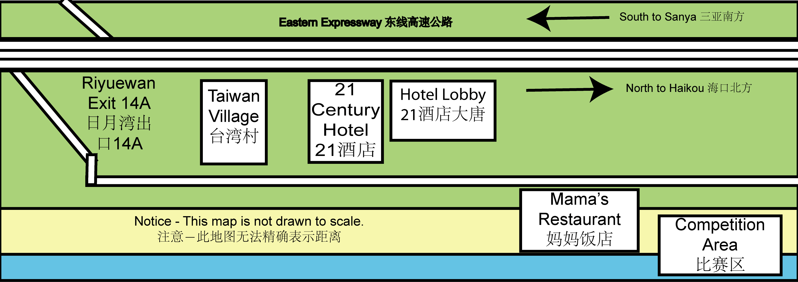

Competition Format
The O’Neill Surfing Hainan Open will have professional and amateur divisions for shortboard and longboard. We will also, for the first year, have a Stand Up Paddleboard division, open to Professional and Amateurs alike.
Entry Fee is 400 rmb and 100 rmb for each additional division. To be paid during mandatory check-in at our Registering Table at 21 Hotel. See below schedule for times. The heat order will depend upon conditions. For example, if Day One is forecasted to be larger then Day Two, we will run mostly shortboard on Day One. The heat order will be decided and published by 6 PM on Saturday, November 6th.
Awards will be given for the top four performers in each of the five divisions. Additional awards will go to Best Local Surfer, Best Wipeout, Best Wave, and Best Female.

Competition Schedule
Friday, Nov 5th
11:00 | Bus to from Surfing Hainan to Riyuewan
Saturday, Nov 6th
11:00 | Bus to from Surfing Hainan to Riyuewan
11:00-15:00 | Registration Table at 21 Hotel Lobby
19:00-22:00 | Registration Table at 21 Hotel Lobby
Sunday, Nov 7th
7:00-7:30 | Registration Table at 21 Hotel Lobby
8:00 | Competitors Briefing at Comp Area
8:30 | Competing Begins
12:10-13:30 | Lunch Break
14:00 | Comp Resumes
18:00 | Competing Concludes for the Day
19:00 | Dinner at Mama's for Competitors
Monday, Nov 8th
9:00 | Competing Begins
13:00 | Competing Concludes
14:00 | Prize-Giving Lunch

The O’Neill Surfing Hainan Open will have a professional and amateur division for both shortboard and longboard division The SUP Division will be open to both professional and amateur.
The heat order will depend upon conditions. For example, if Day One is forecasted to be larger then Day Two, we will run mostly shortboard on Day One. The heat order will be decided and published by 6 PM on Saturday, November 6th.
Awards will be given for the top four performers in each of the five divisions. Additional awards will go to Best Local Surfer, Best Wipeout, Best Wave, and Best Female.

Competition Rules and Tips
Heats and Finals will be 4 man, 20 minutes with best 2 waves counted(15 wave maximum) Finals are 25 minutes.

Please be ready for your heat 30 minutes before it starts.

Interferences: We will be surfing Riyuewan – a left-hand point break – So the rider closest to inside of the breaking wave has priority. If you drop-in and interfere you will be given an interference call, meaning one of your best waves counted will be 50% of lowest wave scored (International Surfing Association “ISA” rules)

We will have flags and a siren to indicate start and end of heats:
Red = No heat running
Green = Heat running
Yellow = 5 minutes remaining in heat
Heats will be water start – meaning you must be in the water when your heat starts. We advise paddling out at least five minutes before end of previous heat. There will be very little break between heats.

Make sure you are wearing the correct color rash vest! Colors are written next to your name on heat board schedule. Remember to return the vest to tent immediately after returning from your heat.

While the contest is in progress do not surf in contest area, or you may be penalized.

Please keep checking heat board for heat times, results, updates and any changes.

For the safety of other competitors, and yourself, please wear a leash.

Please watch the surf before your heat to be aware of conditions, take-off spot, frequency of waves, etc.

Wear sunblock and be careful of drinking too much and lying in the sun

The first heat will start at 8:30 on Sunday and 9:00. Please be ready for your heat.

Please refer to schedule board for heat/event times

The O’Neill Surfing Hainan Open follows the ISA Rulebook. Any disputes will be settled by the Arbitration Committee.

Bring water, snacks, sunblock, and anything else you may need considering Riyuewan is a bit remote.

Please know that Riyuewan does not have easy internet access. A 15 minute trip to a neighboring town is necessary to get to an internet café.

Weather-wise, it will be from about 22-25 degrees Celsius. Bring jeans and sweater in case of cold weather. For surfing, bring a 2 mil top for overcast days. Those who get cold easily might want to bring a light wetsuit in case of colder weather.

Please notify Surfing Hainan Open event staff if anyone is in need of medical attention.

